LiveOffice Email Archive
The Wilson School District utilizes an email archive solution called LiveOffice by Symantec. The archive will contain every email ever sent or received by your account for the last seven years, even those emails that have been deleted and removed from your Deleted Items folder. The interface is very straightforward to use.
Your username is your full Wilson email address (i.e. smijoh@wilsonsd.org). If you do not know your LiveOffice password, you can simply click on the “Forgot Password” link and it will email it to you.
To access the new archive, locate the folder in your email folder list that reads “LiveOffice Email Archive”. There is also a link under the Applications list on the Intranet page. When you click on either of these, it will present you with the archive login screen. Once you are logged in you can search for any email by simply typing in the search bar at the top of the page and then clicking on the magnifying glass to search. If you want to do an advanced search you can click on the double down arrow next to the magnifying glass.
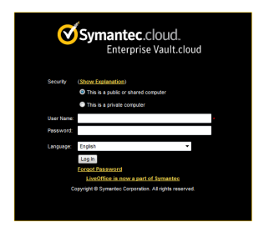
If you have trouble accessing or using your archive, please feel free to contact us for assistance.

